Q1.

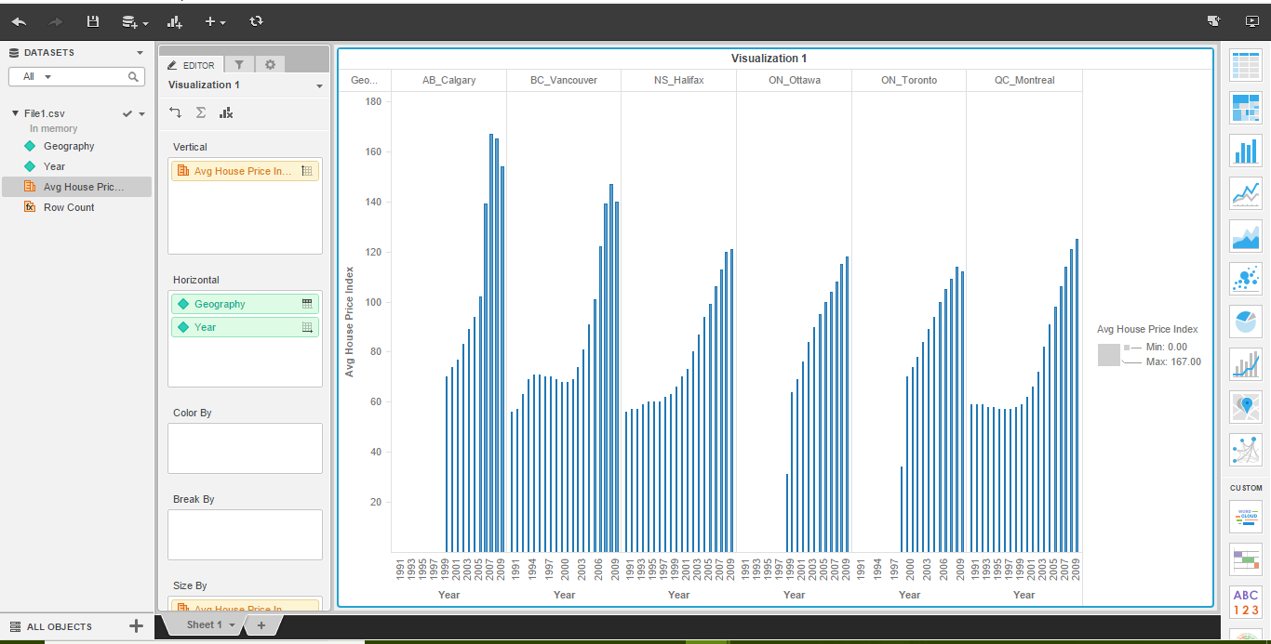

Q2.

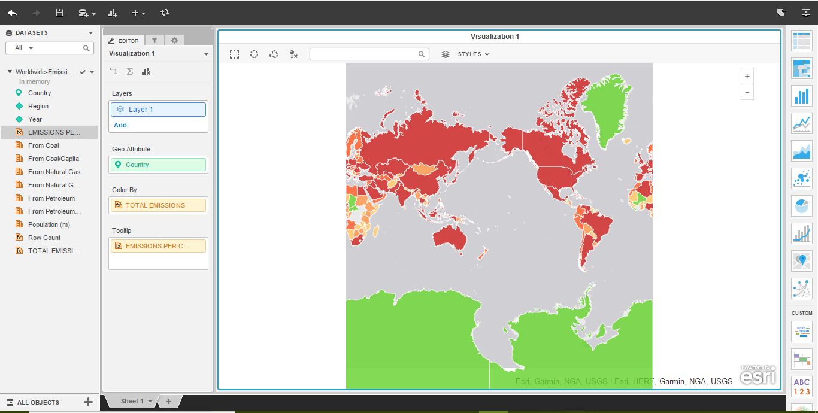

Q3.

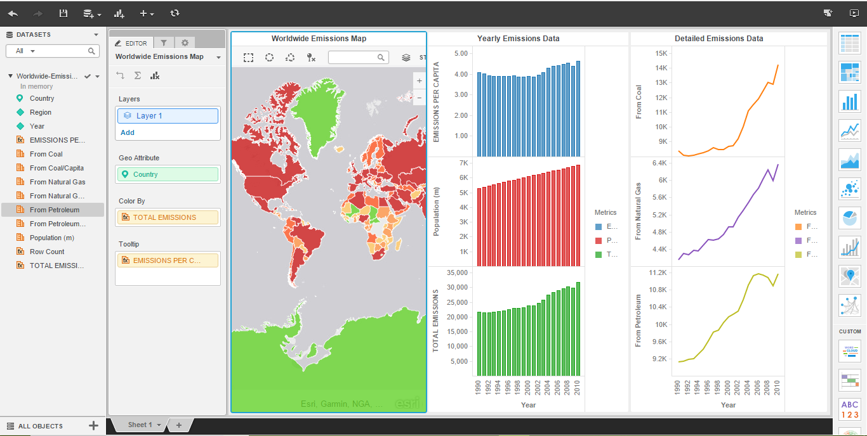

Q4.

1] What is the emissions per capita of Canada?

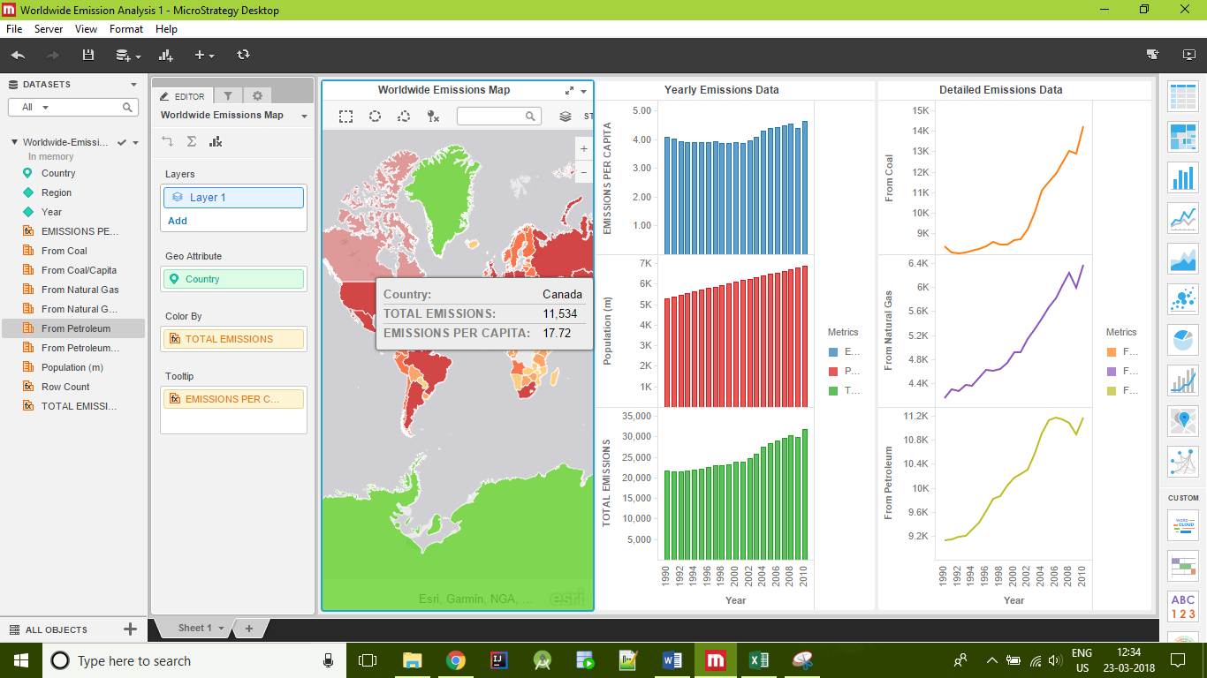

1. 11,534

2] What is the overall trend in worldwide emissions?

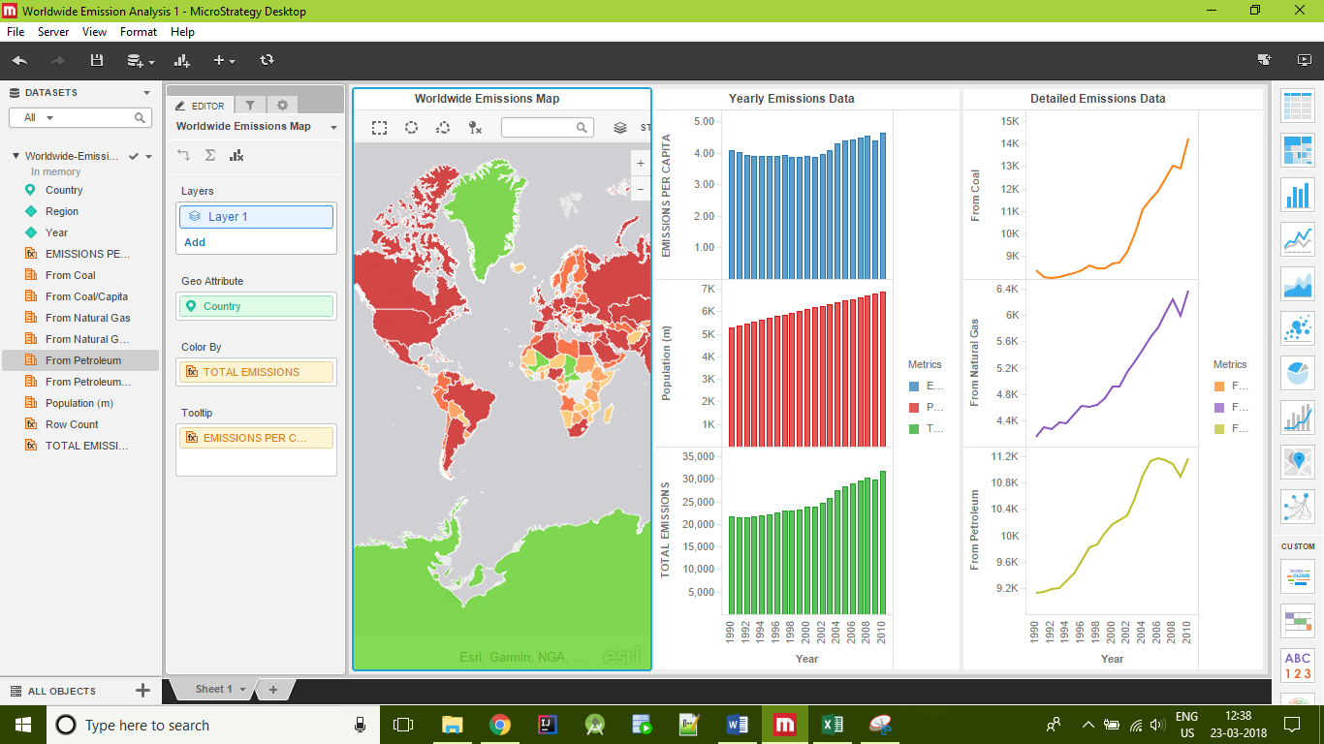

A. Worldwide emissions saw an upward trend uptil 2008. In 2009, there was a dip after which there is a steady growth.

3] Notice that overall emissions declined in 2009, the only year in the total number of years surveyed that indicates emissions decreases in all three emissions sources. Why is that? What broader socio-political context might explain this single yearly decrease?

A. Emissions reduced in the year 2009 because of the recession in the year 2008.

USA in 2009:

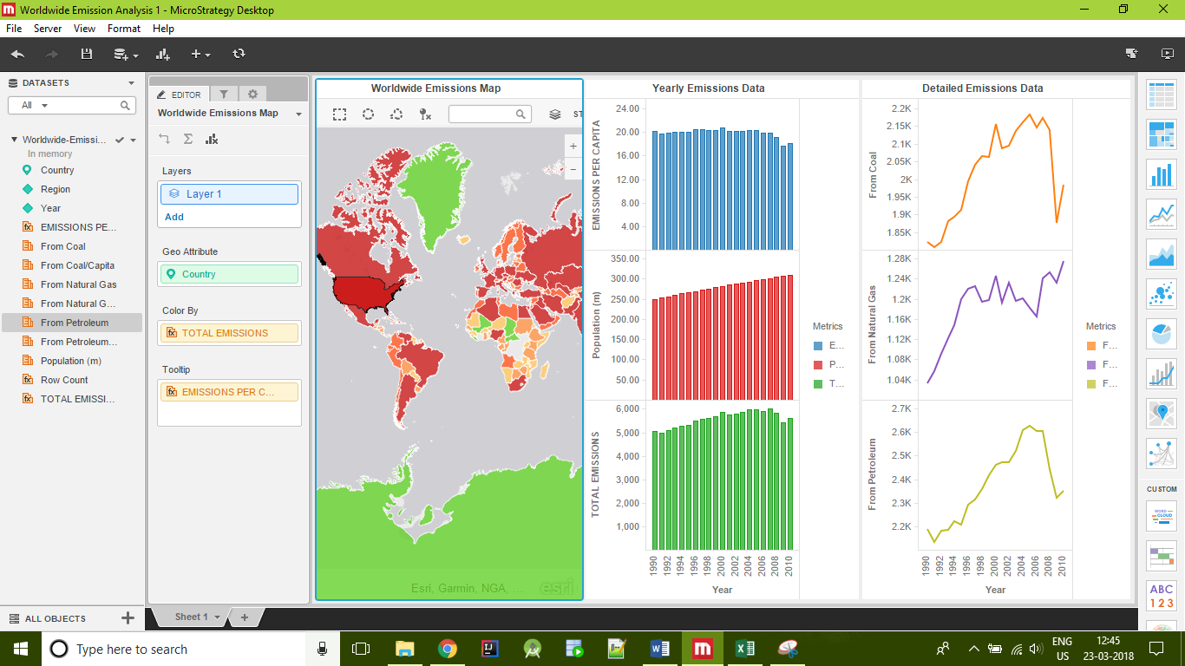

Canada in 2009:

